Deciphering/Decryption
The process of converting from cipher text to plain text is called deciphering.
The following example will explain the procedure for deciphering.
Example 6. Decipher the Cipher text = MOFZ for Key matrix = $\left[\begin{matrix}3 & 3 \\ 2 & 5\end{matrix}\right]$.
Solution: Recall the formula which we used for enciphering
C = KP (mod 26)
Formula for deciphering
P = $K^{-1}C$(mod 26)
$K^{-1}= \frac{Adj(A)}{det⁡(A)}$ (mod 26)
Thus each plain text vector can be recovered from ciphertext vector by multiplying it on the left by $K^{-1}$(mod 26).
Step 1 First find $K^{-1}$, so det(K) = $\left|K\right|=\left|\begin{matrix}3 & 3 \\ 2 & 5\end{matrix}\right|=15-6=9$
$K^{-1}= \frac{\left[\begin{matrix}5 & -3 \\ -2 & 3\end{matrix}\right]}{9}=9^{-1}\left[\begin{matrix}5 & -3 \\ -2 & 3\end{matrix}\right]$
What is the inverse of 9 modulo 26? Let it be x, then 9x = 1(mod 26)
9.1 = 9 ≠ 1(mod26)
9.2 = 18 ≠ 1(mod26)
9.3 = 27 = 1(mod26)
Hence, $9^{-1}=3 (mod 26)$
Therefore,
$K^{-1}=9^{-1}\left[\begin{matrix}5 & -3 \\ -2 & 3\end{matrix}\right]=3\left[\begin{matrix}5 & -3 \\ -2 & 3\end{matrix}\right]=\left[\begin{matrix}15 & -9 \\ -6 & 9\end{matrix}\right]=\left[\begin{matrix}15 & 17 \\ 20 & 9\end{matrix}\right](mod26)$
Step 2 Now, we will decipher MO first, then we will decipher FZ. For this we take
C = $\left[\begin{matrix}M \\ O\end{matrix}\right]$ = $\left[\begin{matrix}13 \\ 15\end{matrix}\right]$
P = $K^{-1}C$(mod 26) =$\left[\begin{matrix}15 & 17 \\ 20 & 9\end{matrix}\right]\left[\begin{matrix}13 \\ 15\end{matrix}\right]=\left[\begin{matrix}450 \\ 395\end{matrix}\right]$(mod 26) =$\left[\begin{matrix}8 \\ 5\end{matrix}\right]≡\left[\begin{matrix}H \\ E\end{matrix}\right]$
For FZ, C = $\left[\begin{matrix}F \\ Z\end{matrix}\right]$= $\left[\begin{matrix}6 \\ 0\end{matrix}\right]$
and P = $K^{-1}C$(mod 26)= $\left[\begin{matrix}15 & 17 \\ 20 & 9\end{matrix}\right]\left[\begin{matrix}6 \\ 0\end{matrix}\right]=\left[\begin{matrix}90 \\ 120\end{matrix}\right]\left(mod 26\right)=\left[\begin{matrix}12 \\ 16\end{matrix}\right]≡\left[\begin{matrix}L \\ P\end{matrix}\right]$
So all plain text is HELP.
Example 7. Decode the following Hill 2-cipher, which was enciphered by the matrix A= $\left[\begin{matrix}5 & 6 \\ 2 & 3\end{matrix}\right]$
GTNKGKDUSK
Solution: We first find the inverse of A (mod 26) as
$$K^{-1}=3^{-1}\left[\begin{matrix}3 & -6 \\ -2 & 5\end{matrix}\right]=9\left[\begin{matrix}3 & -6 \\ -2 & 5\end{matrix}\right]$$
$$=\left[\begin{matrix}27 & -54 \\ -18 & 45\end{matrix}\right]\left(mod26\right)=\left[\begin{matrix}1 & 24 \\ 8 & 19\end{matrix}\right]$$
Next we write numerical equivalent of cipher text, which is
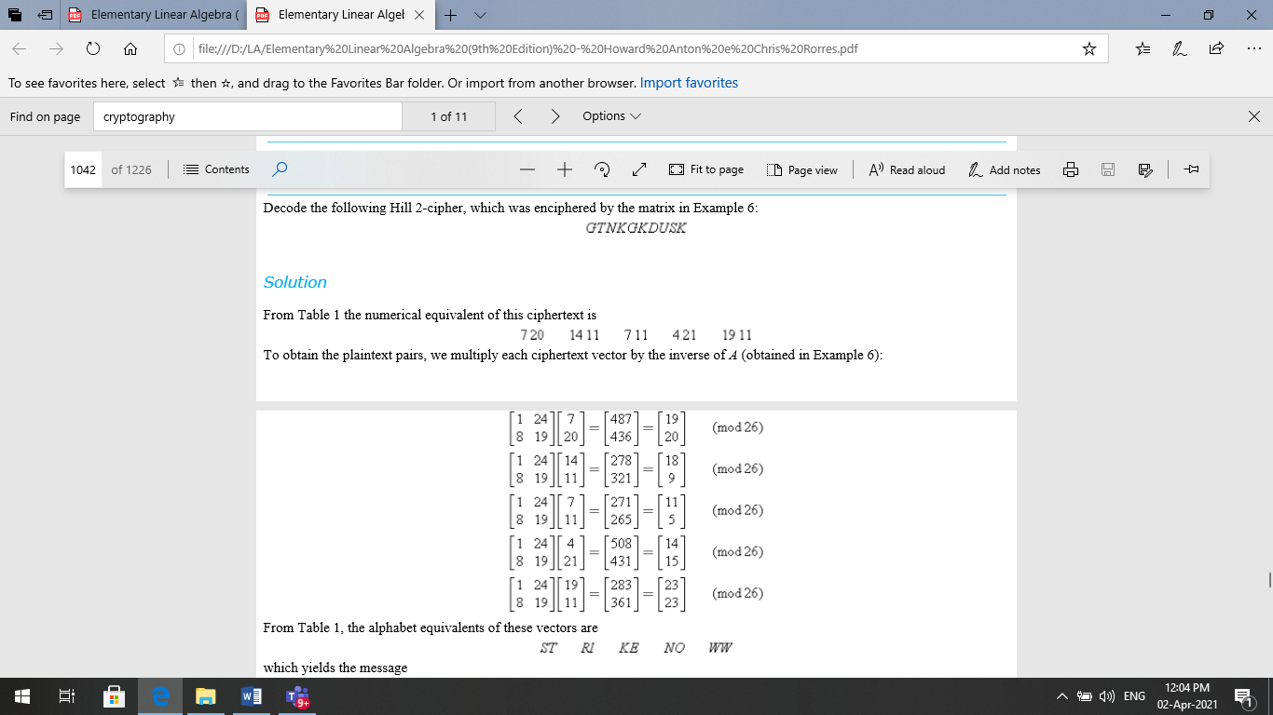

Which yields the message STRIKE NOW

Example 8 Decode 12 17 22 7 11 5
Using $A^{-1}=\left[\begin{matrix}1 & -6 & -8 \\ 0 & 1 & 2 \\ 0 & 1 & 1\end{matrix}\right]$
Solution:
Step 1 $B=\left[\begin{matrix}12 & 7 \\ 17 & 11 \\ 22 & 5\end{matrix}\right]$
$A^{-1}B$ = $\left[\begin{matrix}1 & -6 & -8 \\ 0 & 1 & 2 \\ 0 & 1 & 1\end{matrix}\right]\left[\begin{matrix}12 & 7 \\ 17 & 11 \\ 22 & 5\end{matrix}\right] =\left[\begin{matrix}20 & 5 \\ 9 & 21 \\ 13 & 16\end{matrix}\right]$
That corresponds to $\left[\begin{matrix}T & E \\ I & U \\ M & P\end{matrix}\right]$ means Time up
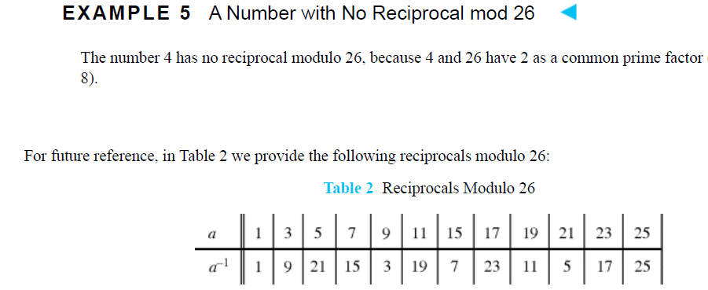
Work to do
Question 1. Determine whether the matrix is invertible modulo 26. If so, find its inverse modulo 26 and check your work by
$$AA^{-1}=A^{-1}A=I(mod 26)$$
a) A= $\left[\begin{matrix}9 & 1 \\ 7 & 2\end{matrix}\right]$ b) B = $\left[\begin{matrix}1 & 8 \\ 1 & 3\end{matrix}\right]$ c) C= $\left[\begin{matrix}2 & 1 \\ 1 & 7\end{matrix}\right]$

Question 2.
Decode the following Hill 2-cipher which was enciphered by the matrix $\left[\begin{matrix}4 & 1 \\ 3 & 2\end{matrix}\right]$
SAKNOXAOJX
Question 3.
Decode the Hill 3-cipher XCVAFA which was enciphered by the matrix key
$\left[\begin{matrix}1 & 2 & 0 \\ 0 & 1 & 2 \\ 0 & 1 & 1\end{matrix}\right]$

